# Student Stress Factors: A Comprehensive Analysis

In this part we take a student stress factors dataset- [data](https://www.kaggle.com/datasets/rxnach/student-stress-factors-a-comprehensive-analysis)  and try to predict the stress levels of students based on various aspects from their daily life. This dataset consists of 20 high impact features of around 1000 students which fall into the following major categories:

Psychological Factors : 'anxiety_level', 'self_esteem', 'mental_health_history', 'depression',

Physiological Factors : 'headache', 'blood_pressure', 'sleep_quality', 'breathing_problem

Environmental Factors : 'noise_level', 'living_conditions', 'safety', 'basic_needs',

Academic Factors : 'academic_performance', 'study_load', 'teacher_student_relationship', 'future_career_concerns',

Social Factor : 'social_support', 'peer_pressure', 'extracurricular_activities', 'bullying'

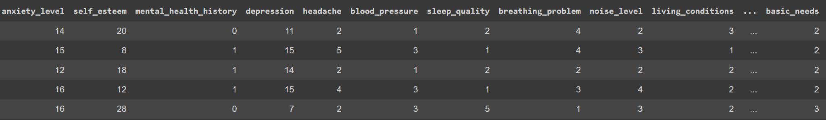

This task can be viewed as a tabular classification task where we can leverage the tubular techniques like decision models in order to predict the stress level of students based on the Psychological, Physiological, Social, Environmental, and Academic Factors. We use one of the most popular and best models available, the XGBoost model.

## 

## CODE:

## Installation

Pip install pandas xgboost sklearn

## Imports

Import pandas as pd

from sklearn.model_selection import train_test_split

from xgboost import XGBClassifier

## Data Loading

df = pd.read_csv('/content/StressLevelDataset.csv')

X= df.drop(columns=['stress_level'],axis=1)

y= df['stress_level']

## Data processing

X_train, X_test, y_train, y_test = train_test_split(X, y, test_size=0.33, random_state=42)

## Model Building

bst = XGBClassifier()

bst.fit(X_train, y_train)

bst.score(X_test,y_test)